EXPERIMENT 3
Step by Step Log

Name – Om Sengar UID – 24BAI70606 Section – 24AIT-NTPP-2(B) .
- AIM:
To design and implement a dimensional data model using Microsoft Power BI by transforming transactional data from the Global Superstore dataset into a Star Schema consisting of Fact and Dimension tables for efficient reporting and analytical processing.

- PROCEDURE:
Step 1: Open Microsoft Power BI Desktop.
Launch Microsoft Power BI Desktop.
Step 2: Import the Global Superstore dataset.
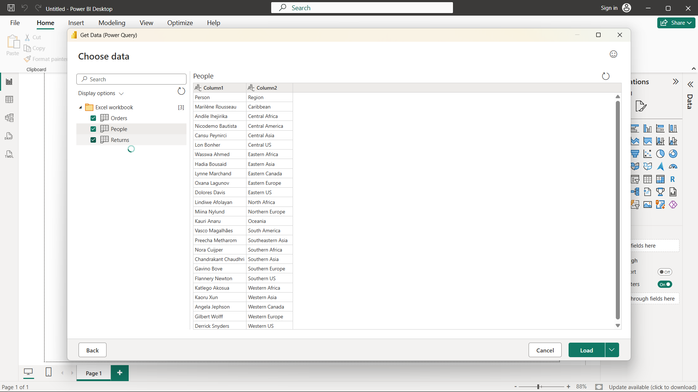
Home > Get Data > Excel Workbook
Select: Global Superstore Dataset.xlsx
Click Load.
Step 3: Select the required worksheets.
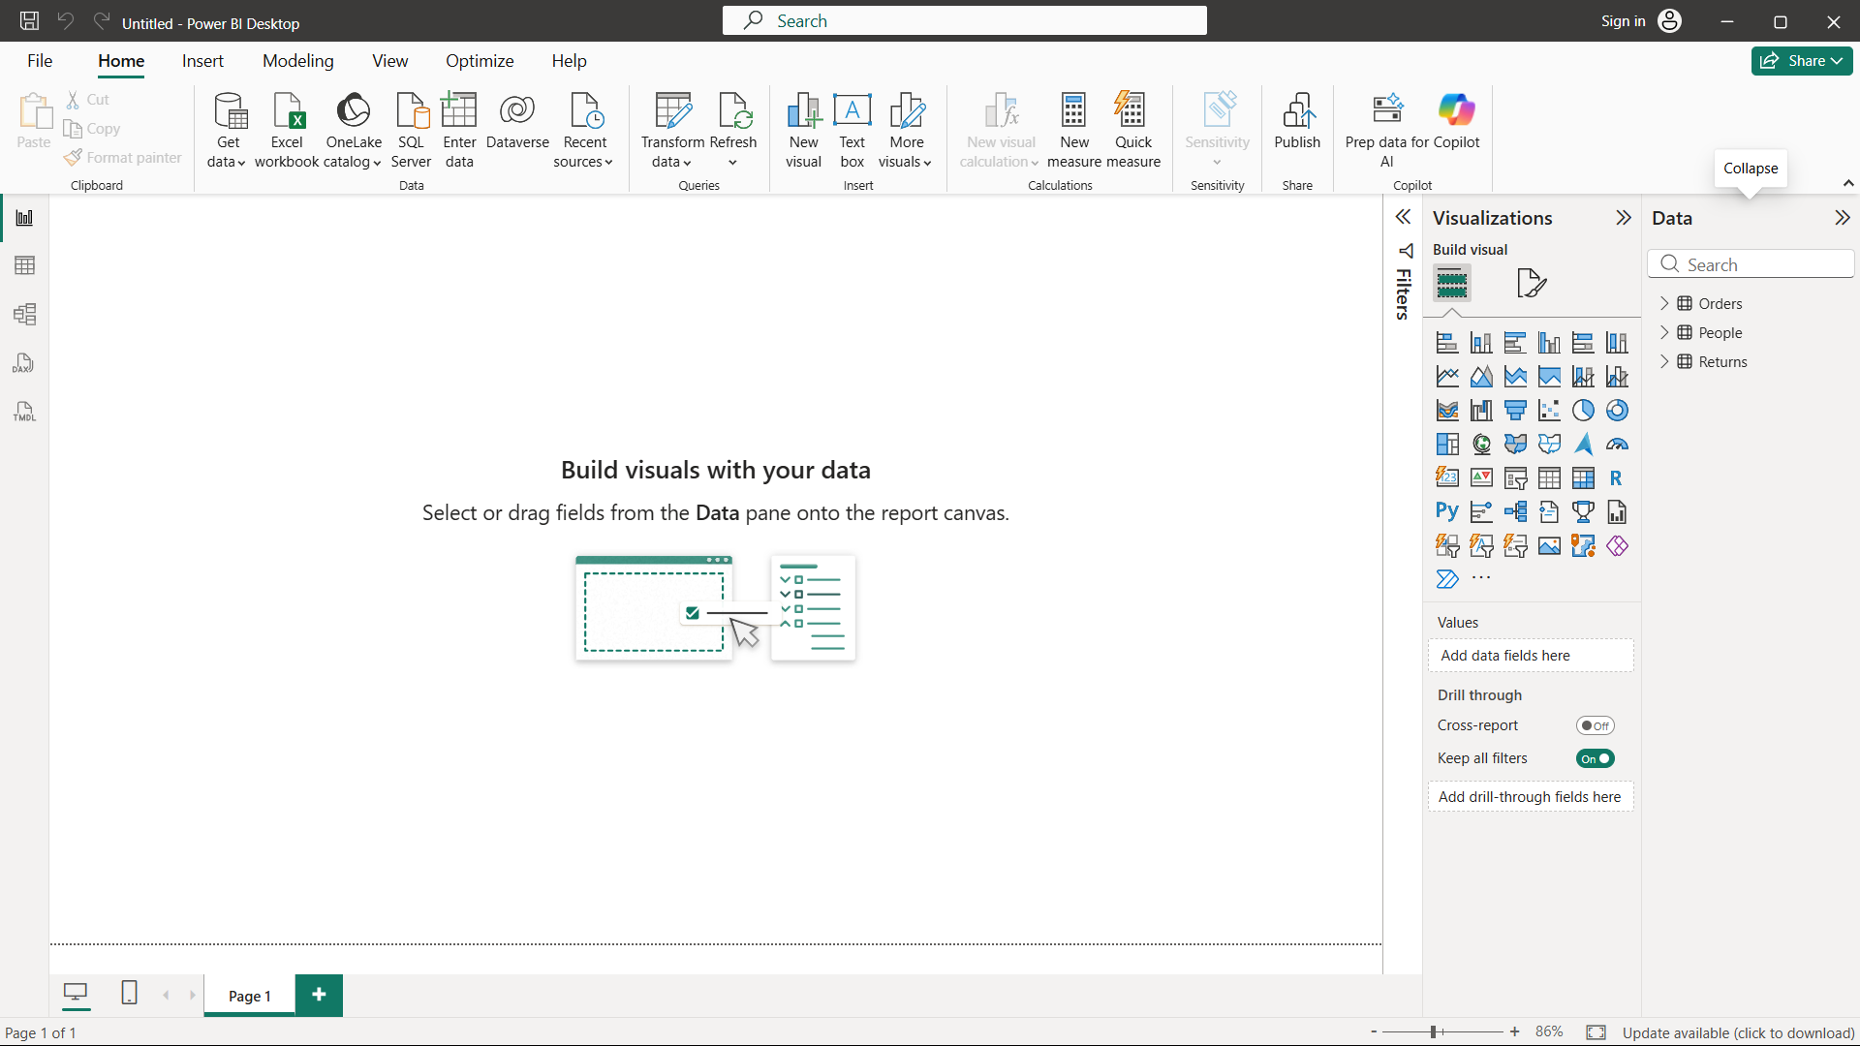
Import the following worksheets:
- Orders
- Returns
- People
Verify that the imported tables appear in Power BI
Step 4: Open Power Query Editor.
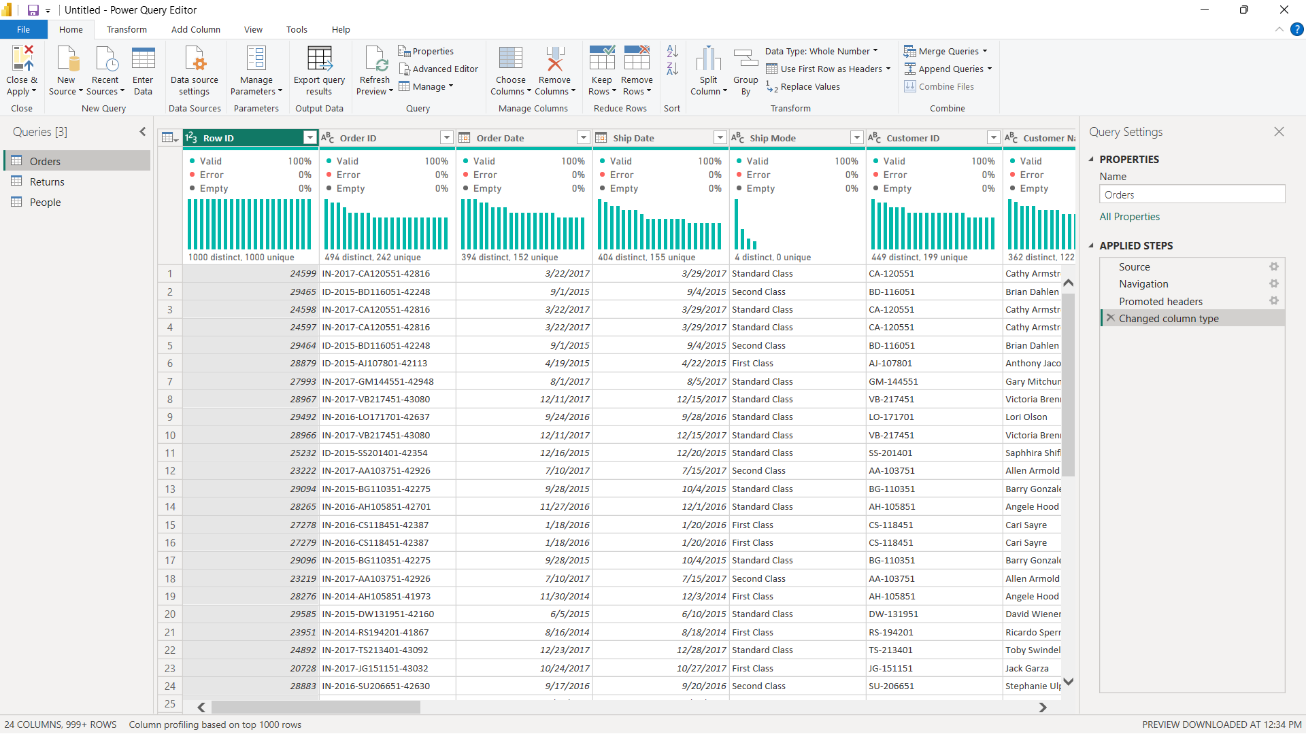
Home > Transform Data
Step 5: Create Dim_Customer.
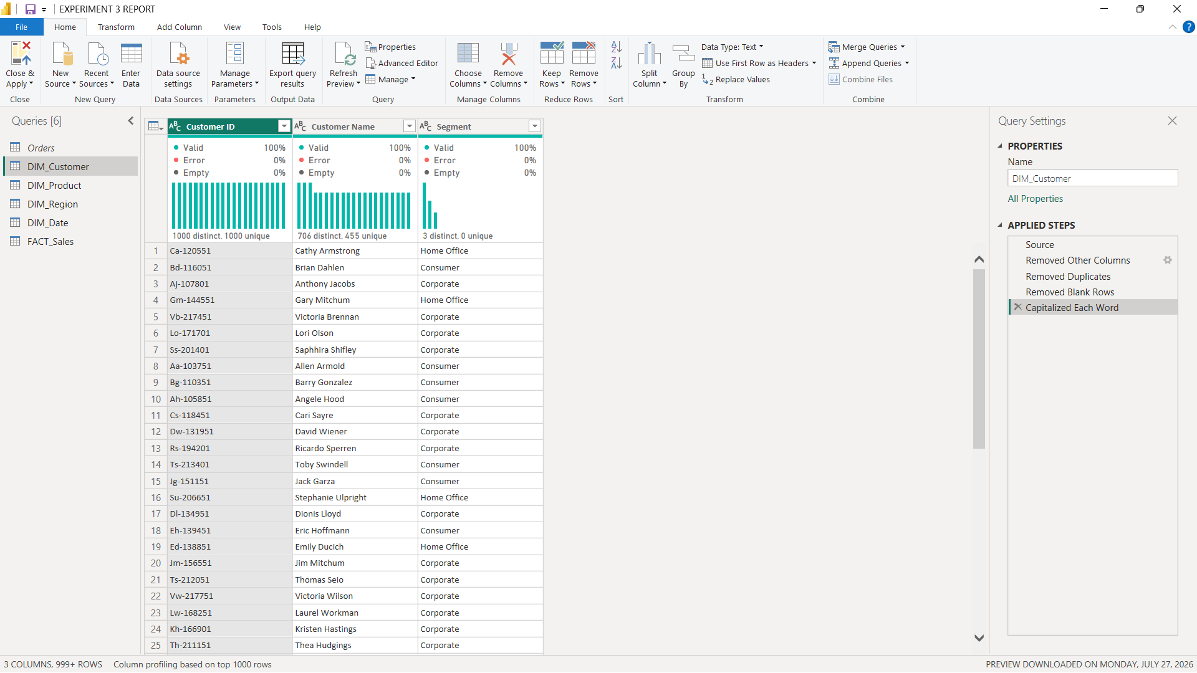
Create a customer dimension containing:
- Customer ID
- Customer Name
- Segment
Remove duplicate records from the dimension.
Step 6: Create Dim_Product.
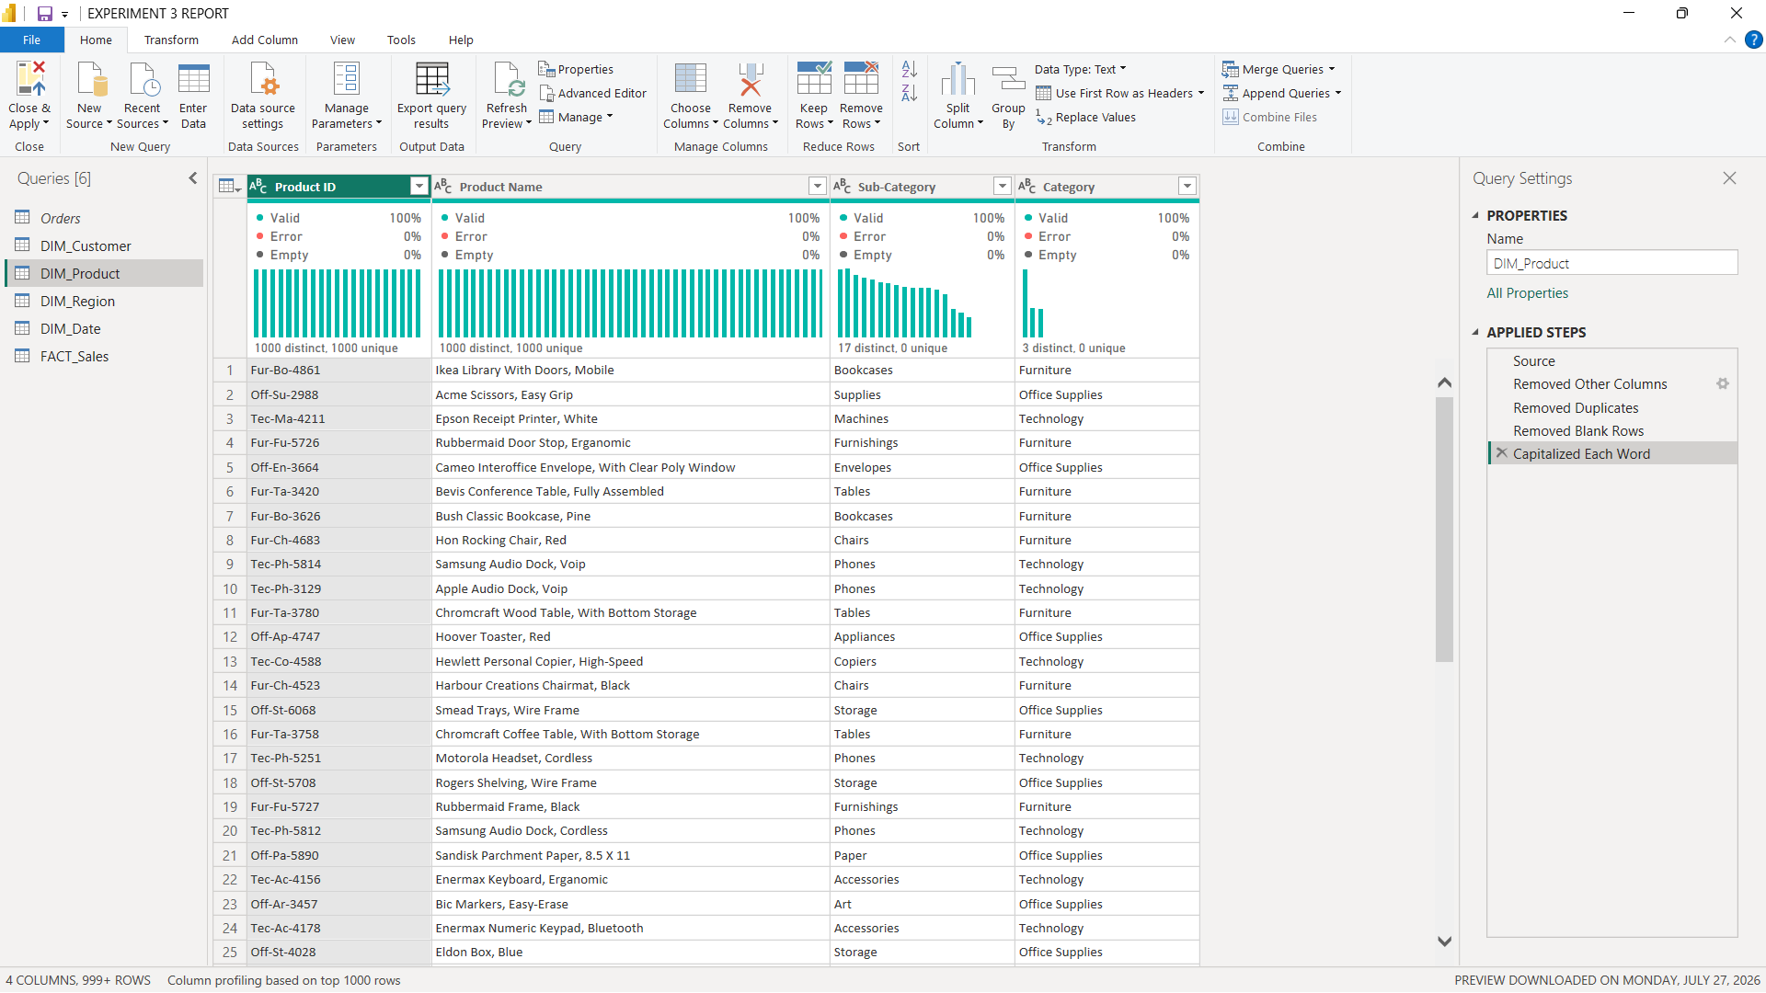
Create a product dimension containing:
- Product ID
- Product Name
- Category
- Sub-Category
Remove duplicate records.
Step 7: Create Dim_Region.
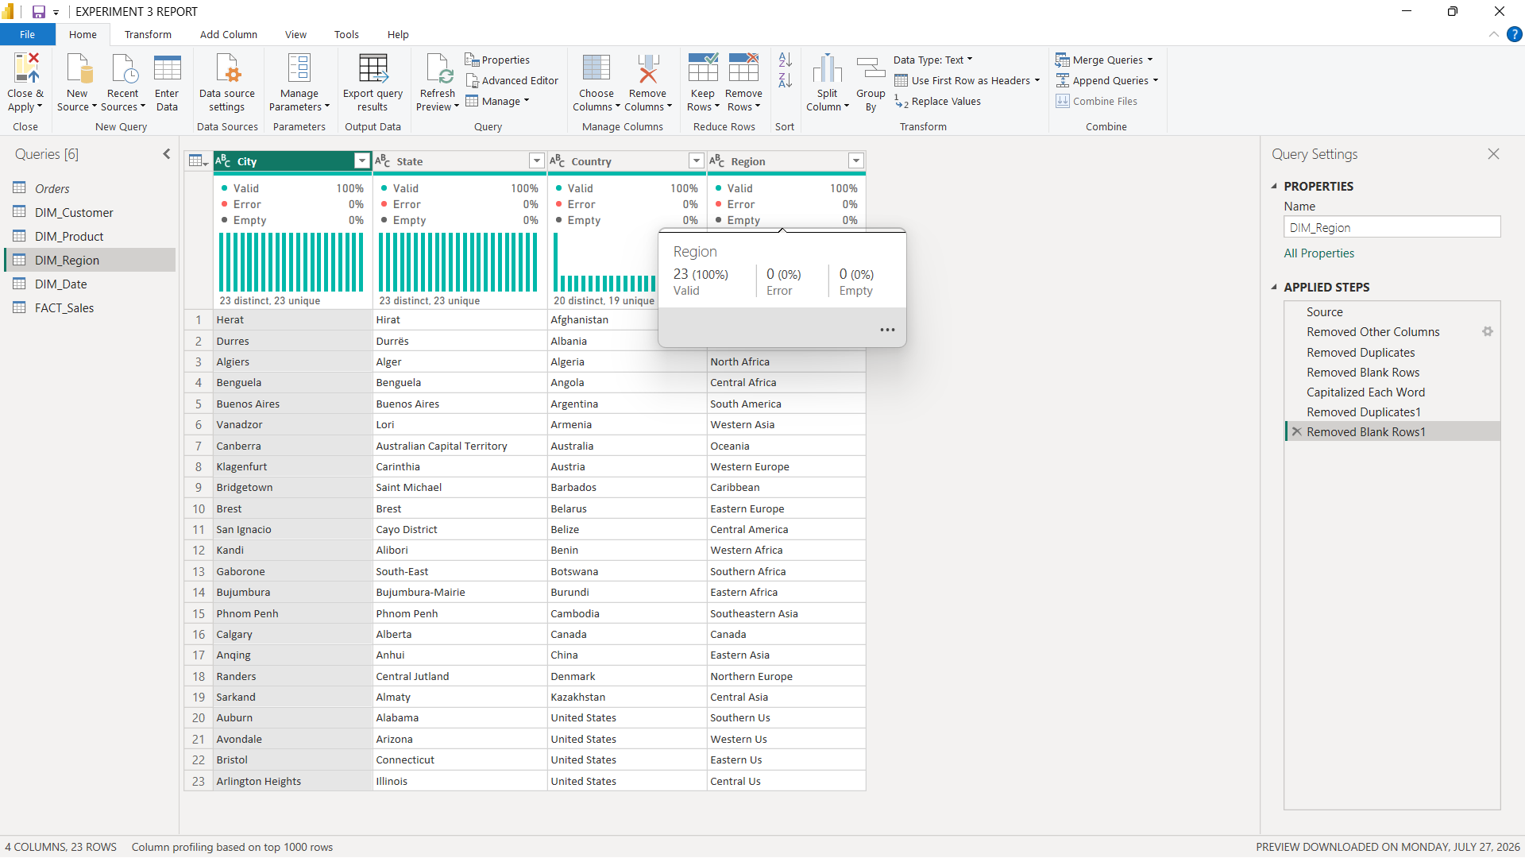
Create a region dimension containing:
- Region
- Country
- State
- City
Remove duplicate records.
Step 8: Create Dim_Date.
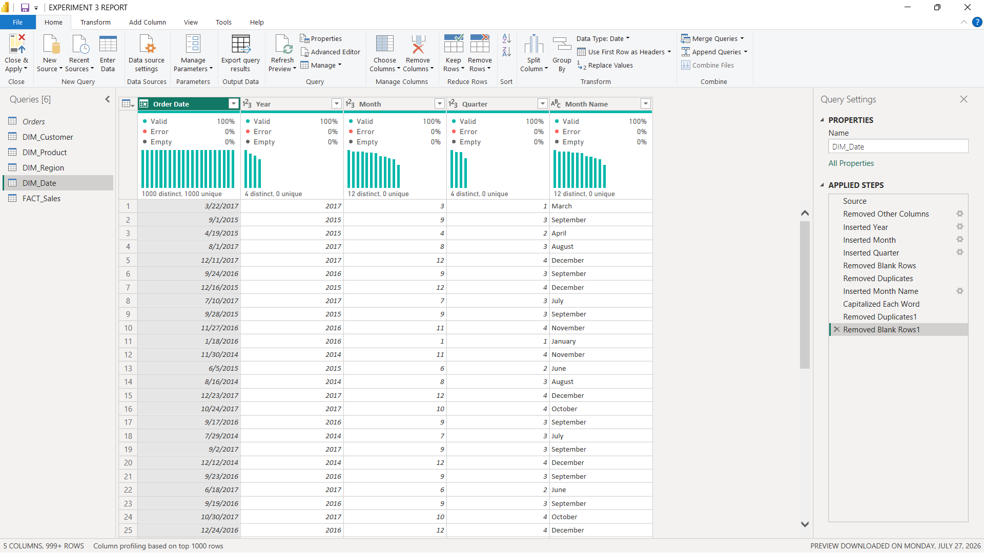
Create a date dimension containing:
- Order Date
- Year
- Quarter
- Month
Ensure that the date-related fields are correctly formatted.
Step 9: Remove duplicate records.
Remove duplicate records from all dimension tables and verify that the key fields . contain unique values.

Step 10: Create Fact_Sales.
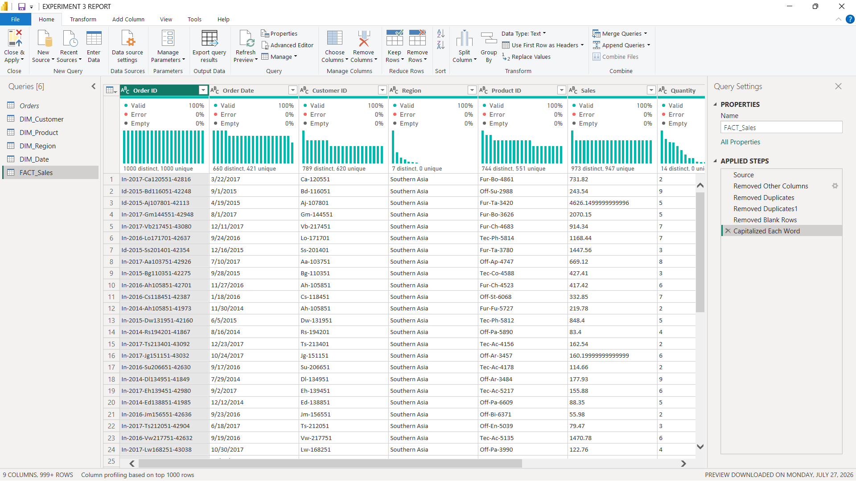
Create the central Fact Table containing:
- Order ID
- Customer ID
- Product ID
- Region
- Order Date
- Sales
- Quantity
- Profit
- Discount
Step 11: Verify key columns.
Verify that all key columns required to establish relationships with the Dimension Tables . are present and correctly formatted.
The resulting Fact_Sales table acts as the central table of the Star Schema.
Step 12: Open Model View.
Select the Model View icon from the left navigation pane in Power BI.
Step 13: Create relationships.
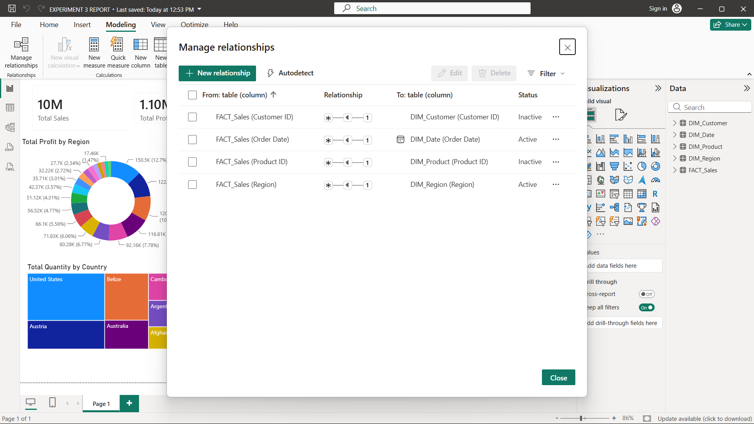
Create relationships between:
- Fact_Sales ↔ Dim_Customer
- Fact_Sales ↔ Dim_Product
- Fact_Sales ↔ Dim_Region
- Fact_Sales ↔ Dim_Date
Configure relationships.
Set the relationships appropriately as Many-to-One, with the Fact Table on the many . side and the corresponding Dimension Table on the one side.
Step 14: Arrange the model.
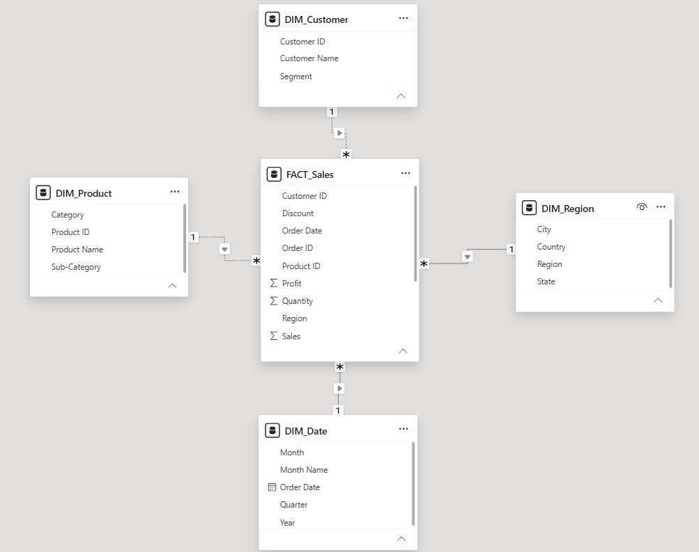
Arrange the tables visually so that:
Dim_Customer
│
│
Dim_Product ───── Fact_Sales ───── Dim_Region
│
│
Dim_Date
This forms the Star Schema with Fact_Sales at the centre and the Dimension Tables . . surrounding it.
Step 15: Create Power BI visualizations.
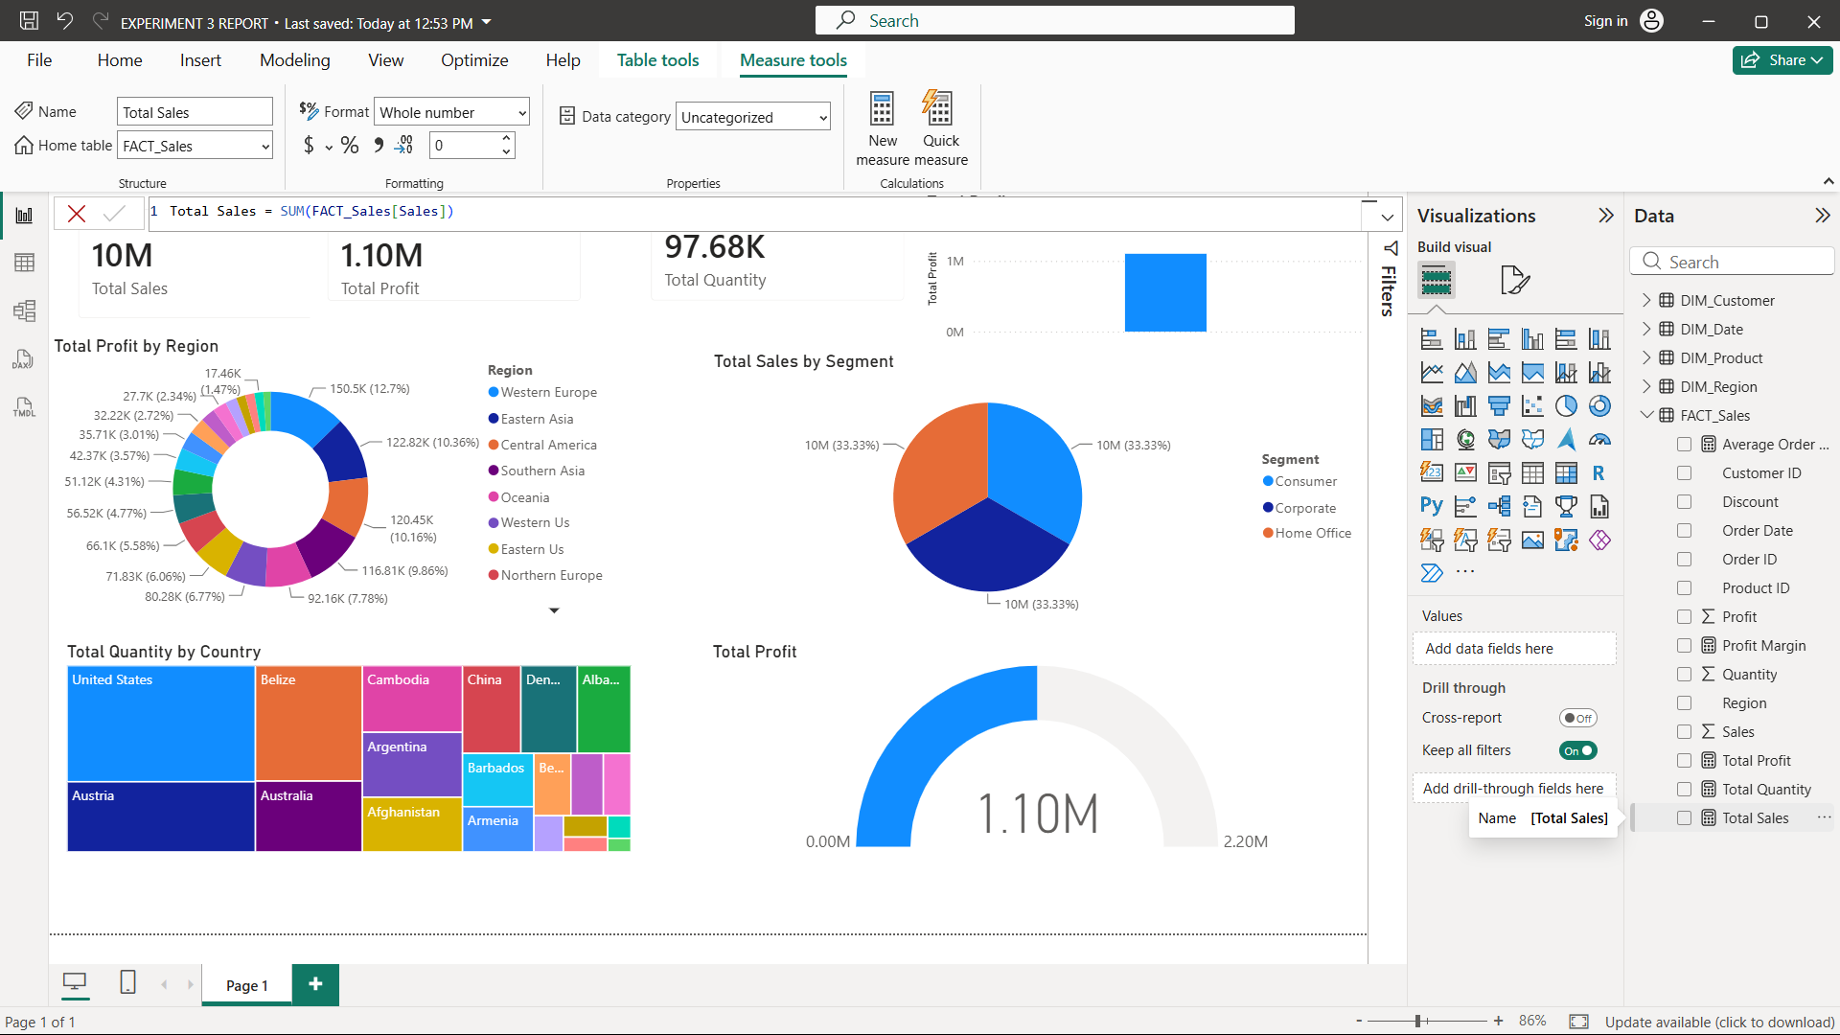
Create visualizations using the dimensional model to analyse the data.
Examples include:
- Sales by Category
- Profit by Region
- Sales Trend by Year
The reference specifies these as examples of visualizations for validating the model.
Step 16: Create DAX measures.
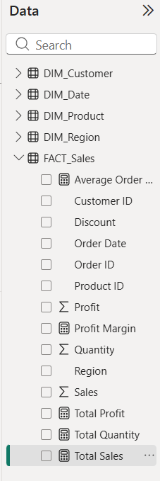
Create the following measures:
  - Total Sales = SUM(Fact_Sales[Sales])
  - Total Profit = SUM(Fact_Sales[Profit])
  - Profit Margin = DIVIDE(SUM(Fact_Sales[Profit]),SUM(Fact_Sales[Sales]))
  - Average Order Value = DIVIDE([Total Sales],DISTINCTCOUNT(Fact_Sales[Order ID]))
Step 17: Validate the Star Schema.
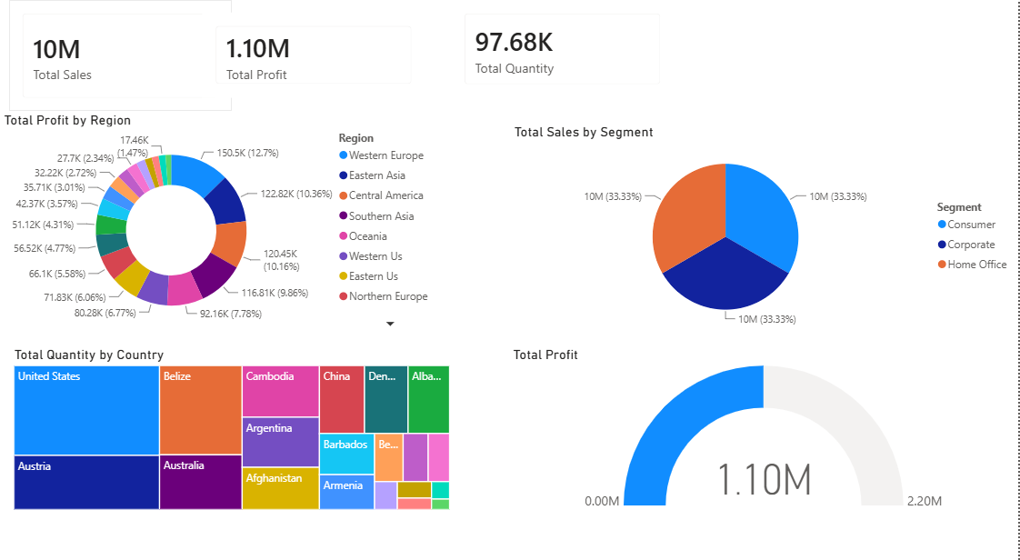
Use the created Dimension Tables to filter the Fact Table and verify that the . . . relationships work correctly.
Check that changes in dimensions such as Customer, Product, Region, and Date correctly . affect the corresponding Fact Table data and dashboard visualizations.

- LEARNING OUTCOMES
- Understood the ETL process and its role in Business Intelligence.
- Learned how to extract data from a real-world business dataset using Power BI.
- Gained practical experience with Power Query Editor.
- Learned how to clean, filter, transform, and merge datasets.
- Learned how to handle duplicate records, blank values, and data type inconsistencies.
- Learned how to create relationships between multiple tables in Power BI.
- Learned how to create analytical measures using DAX.
- Understood the use of Total Sales, Total Profit, Profit Margin, and Total Orders measures.
- Learned how to create BI visualizations and dashboards for business analysis.
- Gained practical experience in preparing transformed data for reporting and decision-making.

